**Seminar Report 4**

DING Yibo 2186113548

**Topic 1**

1. **Topic**

Boost Converter

1. **Simulation Model**

In this part, the simulation is regarding boost converter, and the simulation is based on the circuit diagram shown below:

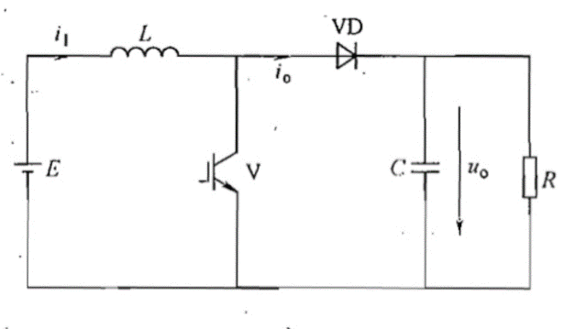

Fig.1-1 Circuit diagram of boost converter

The simulation model is shown below:

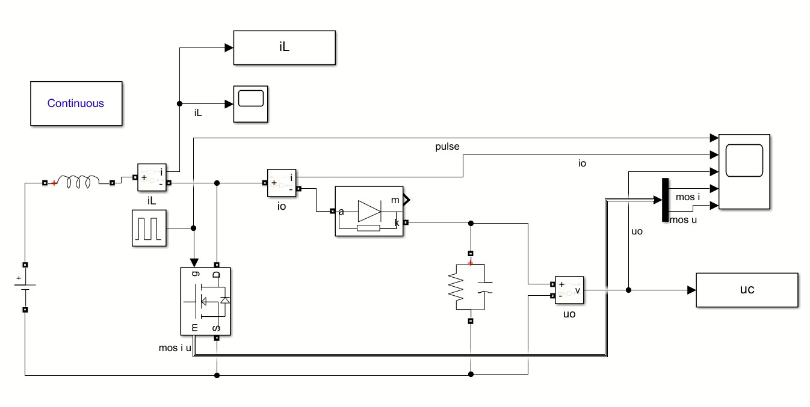

Fig.1-2 Simulation model of boost converter

This model is established to analyze the inductor current ripple, the capacitor voltage ripple and voltage gain when the duty cycle *D* varies from 0.3 to 0.8.

1. **Parameter Setup**

The value of input/output voltage, resistor, frequency, inductor and capacitor are based on the table below:

Tab.1-1 The Given Parameters for Topic1

|  |  |  |  |  |  |
| --- | --- | --- | --- | --- | --- |
| Vin | Vo | RL | fs | L | C |
| 300V | 400V | 100Ω | 100kHz | 800uH | 200uF |

For Task1, the duty cycle *D* could be derived from:

 (1-1)

Therefore, in Task1, .

For Task2, the duty cycle varies from 0.3 to 0.8, we set the step value as to select 50 different values, the specific values would be shown in part4.

1. **Simulation Results & Analysis**

***4-1 Task 1***

***4-1-1 Task requirement***

For given input/output voltage and circuit parameters, we need to calculate the theoretical value of inductor current ripple, capacitor voltage ripple and do simulations to verify the calculation results.

* + 1. ***The theoretical value of inductor current ripple, capacitor voltage ripple***

1. ***Capacitor voltage ripple***

The peak-to-peak ripple in the output voltage could be calculated by considering the waveform below. Assuming that all the ripple current component of diode current  flows through the diode current capacitor and its average value flow through the load resistor because the voltage ripple is very small. The charge  is represented by the shaded area in the following waveform. Therefore, the peak-to-peak voltage ripple is given by

 (1-2)

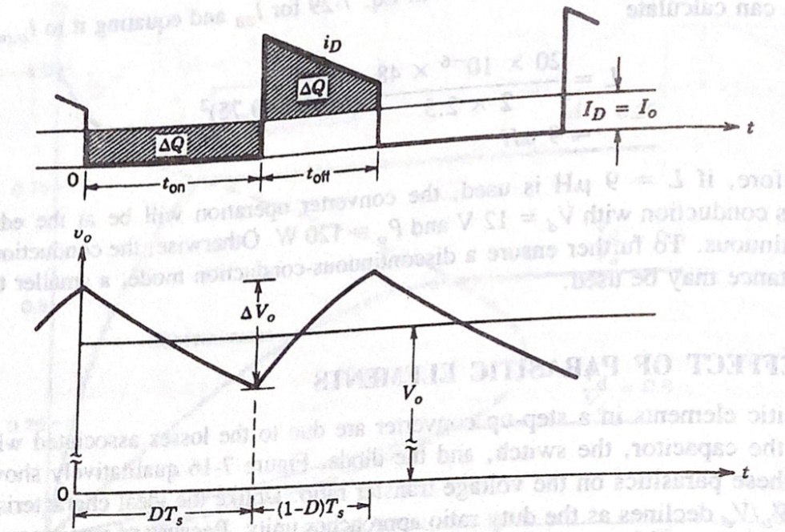

Fig.1-3 Boost converter output voltage ripple

Based on the given parameter, we could calculate our output voltage ripple



1. ***Inductor current ripple***

Similarly, the inductor current ripple could be derived from:



Based on the given parameter, we could calculate our inductor current ripple



What’s more, we could also derive from differential equations based on the definition of ripple, but that’s not so convenient as the method above.

* + 1. ***Relevant waveforms***

In Simulink, we used the cursor in scope to measure the value of ripple.

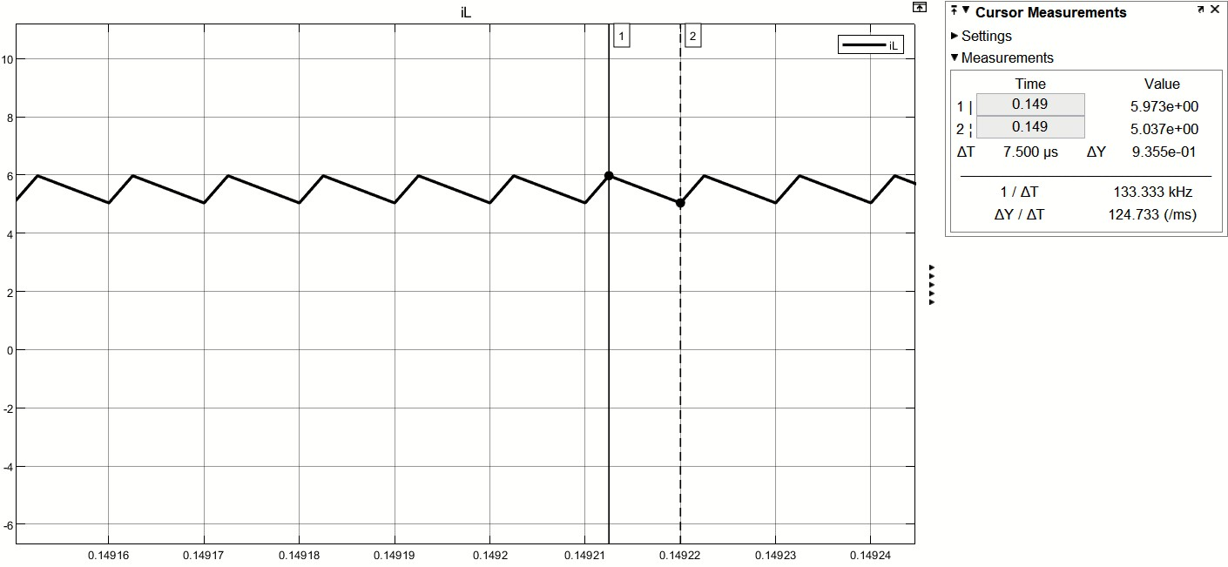

Fig1-2. Simulation model of boost converter

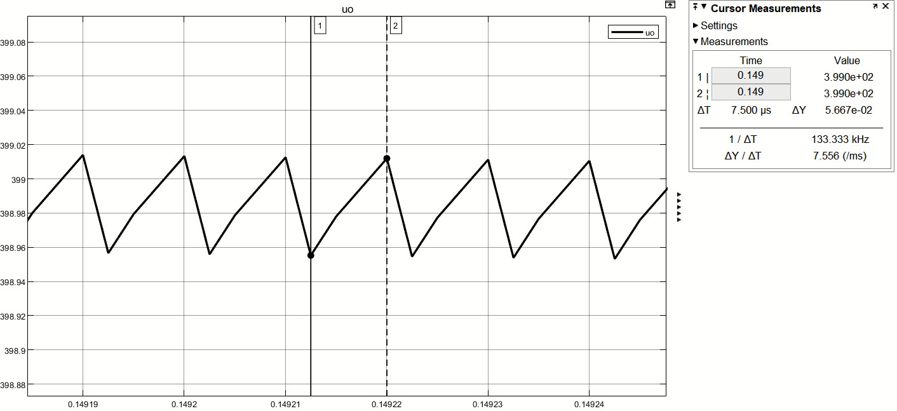

Fig1-2. Simulation model of boost converter

From two figures above, we could know that the output voltage ripple and inductor current ripple are 0.05667V and 0.9355A respectively.

Form1-1. The Given Parameters for Topic1

|  |  |  |
| --- | --- | --- |
|  | Vo | RL |
| Calculation results | 0.05V | 0.9375A |
| Simulation results | 0.05667V | 0.9355A |
| Error | 13.34% | 0.213% |

From the table above, we could conclude that the calculation results and simulation results are almost the same, which shows that our simulation is acceptable.

***4-2 Task 2***

***4-2-1 Relationships between duty cycle D and inductor current ripple***

In our simulation, we get the curve between inductor current ripple and duty cycle as below.

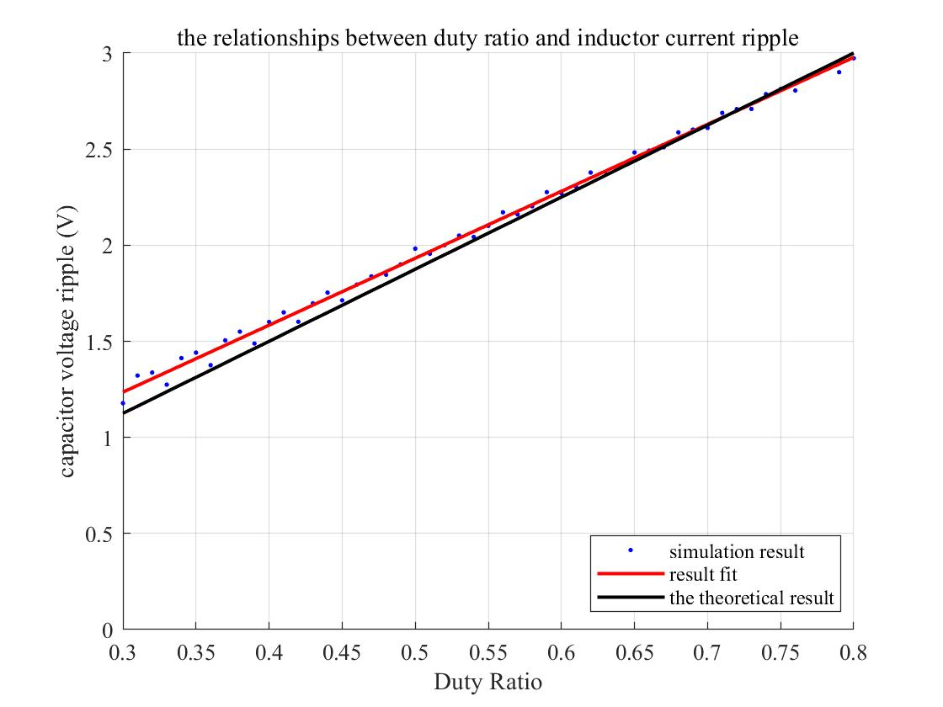

Fig1-2. Simulation model of boost converter

Comparing the simulation results with calculation results, two curves are almost coinciding. The curve of error of simulation about inductor current ripple as the duty ratio increases is shown below:

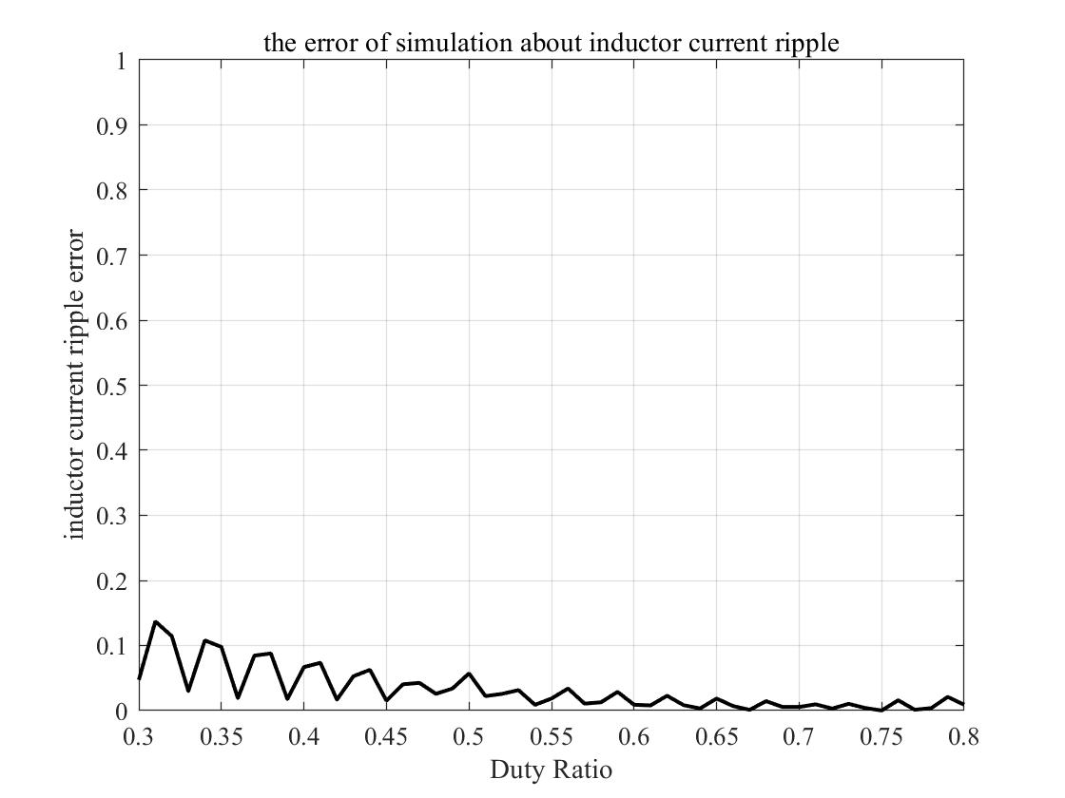

Fig.1-2 Simulation model of boost converter

From Fig.1-x, we could know that the error is about 10% at first and drops slowly as the duty ratio increases, reaching almost zero when duty ratio is about 60%.

***4-2-2 Relationships between duty cycle D and capacitor voltage ripple***

In Simulink, we plot the curve between and .

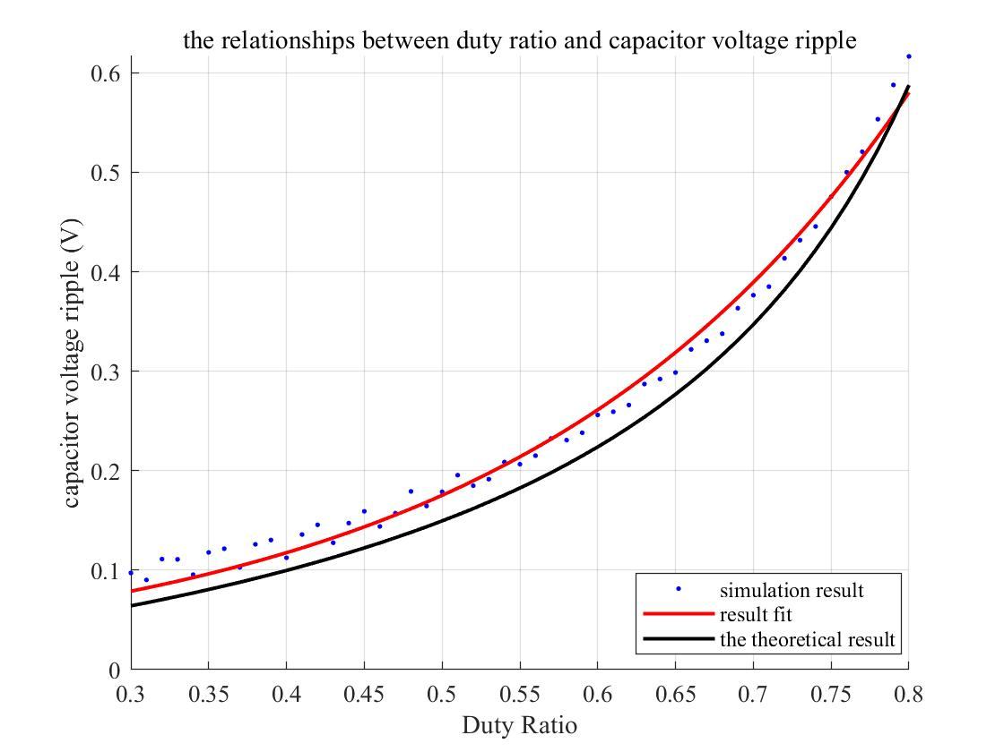

Fig.1-2 Simulation model of boost converter

Similarly, we could conclude that the calculation results and simulation results are basically the same. The reason why the error of capacitor voltage ripple is larger than that of inductor current ripple might be the capacitor voltage ripple is a very small value, so when the two results are slightly different, the error could be a large number. The curve of error is shown below:

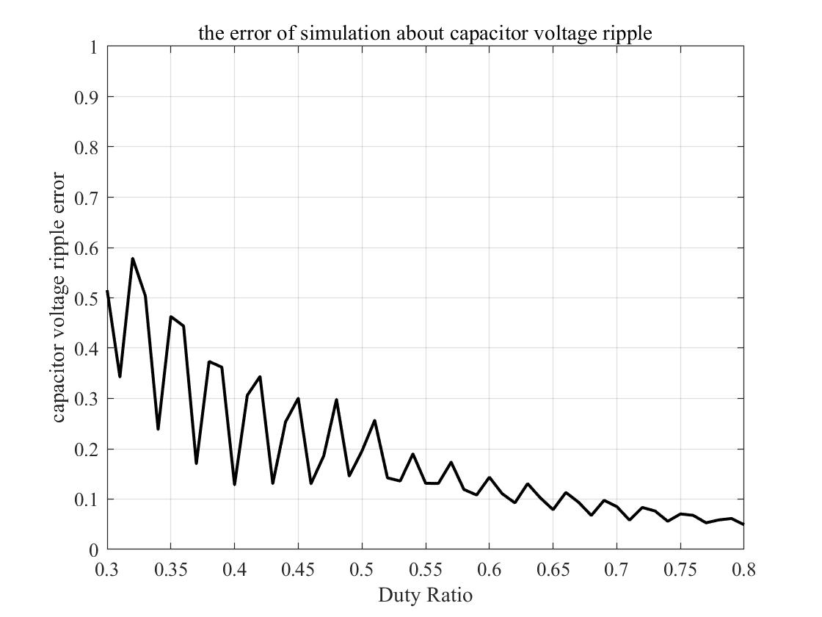

Fig.1-2 Simulation model of boost converter

***4-2-3 Relationships between duty cycle D and voltage gain G***

Based on the definition of voltage gain, we know that:



Therefore, the curve of relationships between duty cycle and voltage gain is shown below. The voltage gain increases as the duty cycle increases.

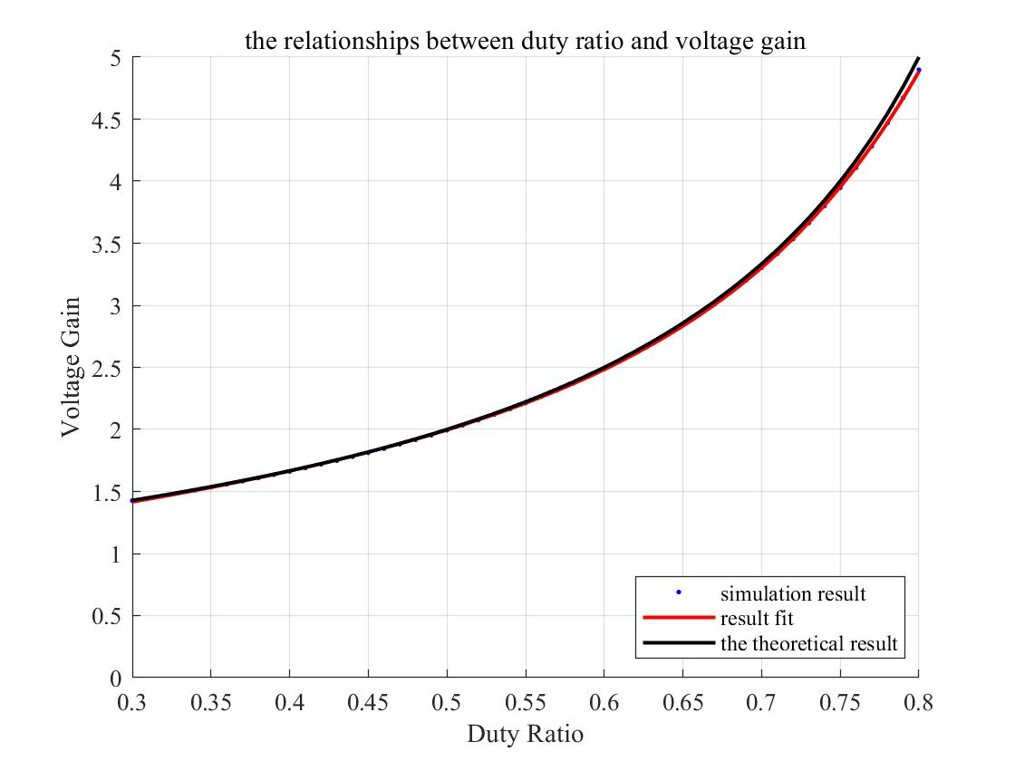

Fig1-2. Relationships between duty ratio and voltage gain

From the figure above, we could conclude that the simulation result is almost the same as the theoretical result. Also we plot the error of voltage gain between calculation results and simulation results to observe the difference, the curve is shown below:

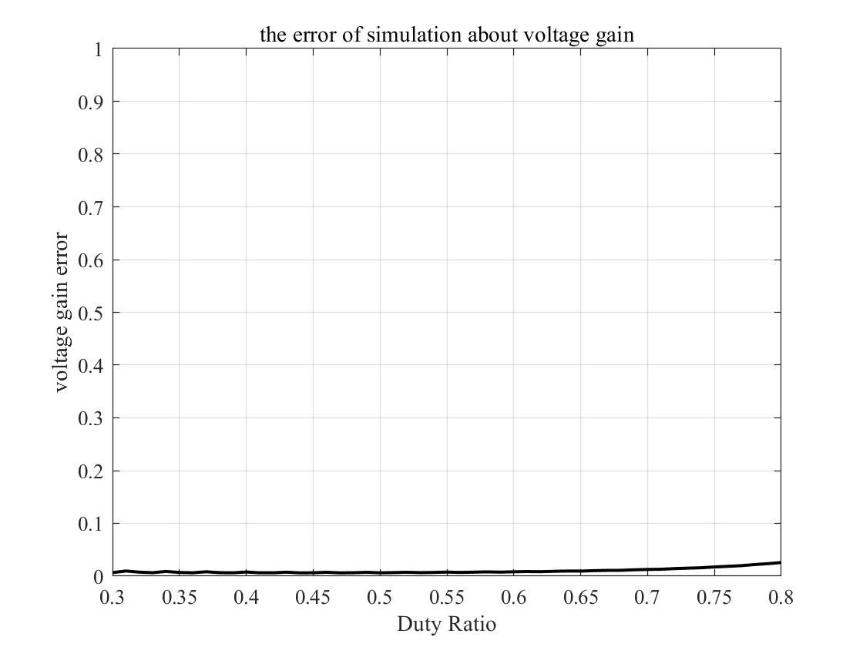

Fig1-2. Relationships between duty ratio and voltage gain

The result is pleasing, there’s almost no error between calculation results and simulation results.

**Topic 2**

1. **Topic**

Full-bridge inverter + Full-wave rectifier

1. **Simulation Model**

We used the model as below in Simulink to carry out the simulation:

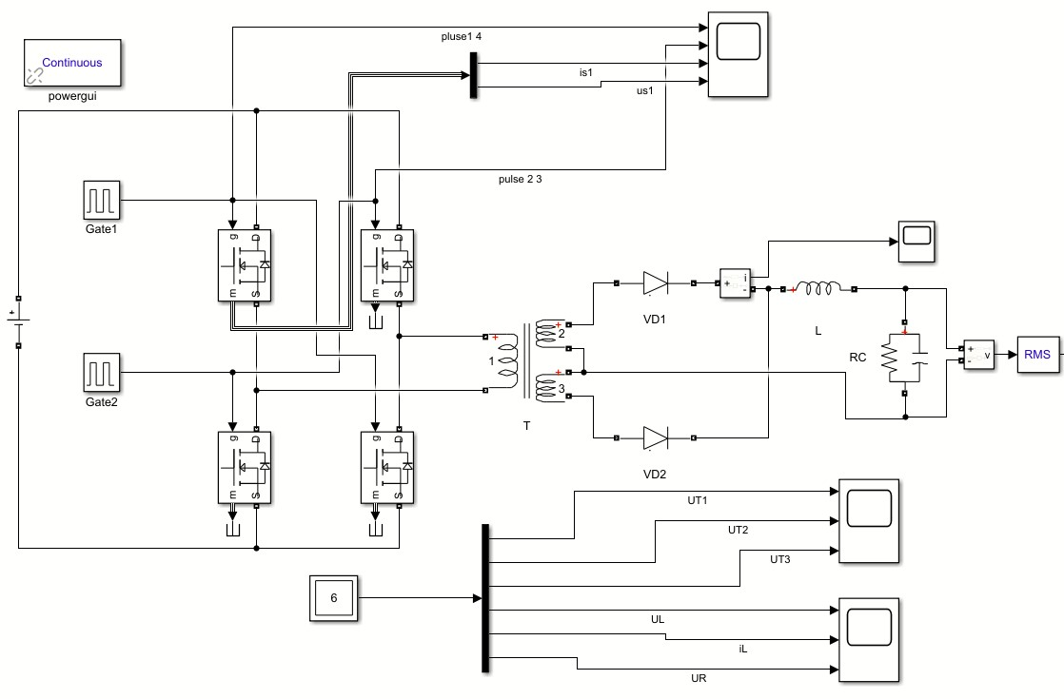

Fig. 2-1 Simulink model for topic2

This model is established to analyze the operating principle and sequence, continuous current mode (CCM) and discontinuous current mode (DCM) as well as the relationships between duty cycle and voltage gain when duty cycle varies.

1. **Parameter Setup**

The parameters are based on the table below:

Table 2-1. The Given Parameters for Topic2

|  |  |  |  |  |  |  |
| --- | --- | --- | --- | --- | --- | --- |
| Vin | Vo | T | RL | fs | L | C |
| 600V | 48V | 4:1:1 | 10Ω | 100kHz | 300uH | 200uF |

In the circuit, we know that:



Therefore, to make the output voltage 48V, we set the duty ratio to 16%.

1. **Simulation Results & Analysis**

***4-1 Task 1***

***4-1-1 Task requirement***

For given input/output voltage and circuit parameters, we need to do simulations to study the operating principle and analyze the operating sequence.

***4-1-2 Operating principle and sequence***

This circuit can be divided into two parts by the transformer, a full-bridge inverter on the left and a full-wave rectifier on the right. Through the inverter, the direct current will be transformed into alternating current. Then, the transformer will convert the voltage level. Owing to the two power diodes, the AC will be converted to DC finally. Therefore, the structure is an indirect DC to DC converter.

***i) Full-bridge inverter***

In the full-bridge inverter, the four MOSFETs are divided into two groups. S1 and S4 are in group 1 and group 2 consists of S2 and S3. MOSFETs in one group conduct together and the two groups conduct alternant. The duty cycle D is defined as the time one group conducts in one period.

We take as an example to learn the principle of circuit. Waveforms of triggering pulses and MOSFET voltage and current are shown as below.

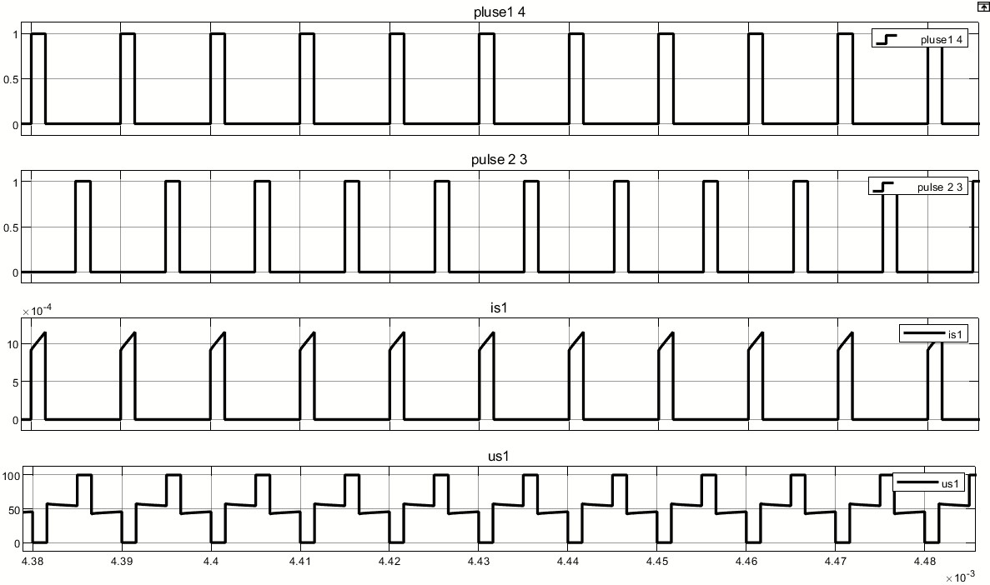

Fig. 2-1 Simulink model for topic2

From the figure, we can easily get operating sequence shown as below.

Table 2-2. Operating sequence

|  |  |
| --- | --- |
| Time interval | Conducting MOSFETs |
| 0-DT | S1, S4 |
| DT-T/2 | \ |
| T/2-(D+1/2) T | S2, S3 |
| (D+1/2) T-T | \ |

***ii) Full-wave rectifier***

The voltage waveforms of primary side and secondary side of the linear transformer are shown below.

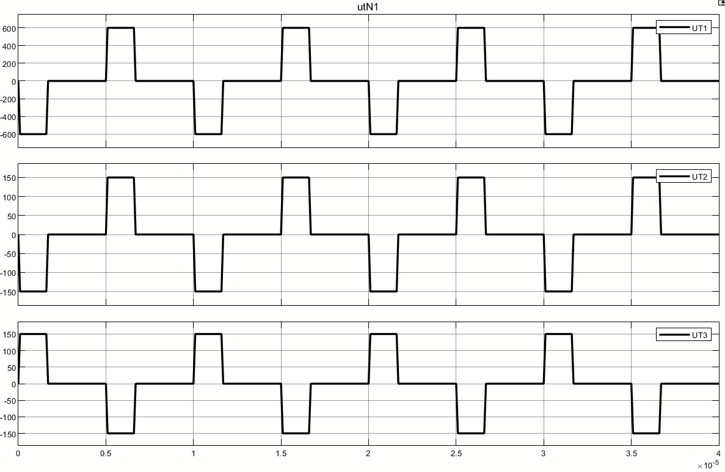

Fig. 2-1 Simulink model for topic2

From the figure, the amplitude value of voltage equals to 600V and 150V on the primary side and secondary side respectively, which fits the ratio of transformation (4:1:1).

For two groups of diodes, each group conducts complementarily.

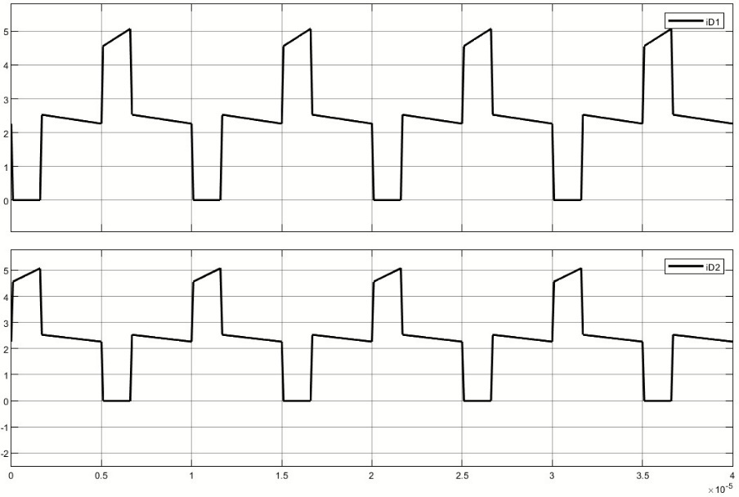

Fig. 2-1 Simulink model for topic2

When S1 and S4 conduct, UT2 is positive and VD1 is at on-state. When S2 and S3 conduct, UT2 is negative and VD2 is at on-state. If the four MOSFETs are all at off-state, the inductor discharges through the two diodes.

The figure below shows the value of output voltage, we measure the value by using the cursor in scope. We could know that the output voltage is exactly 48V, the same as the calculation result.

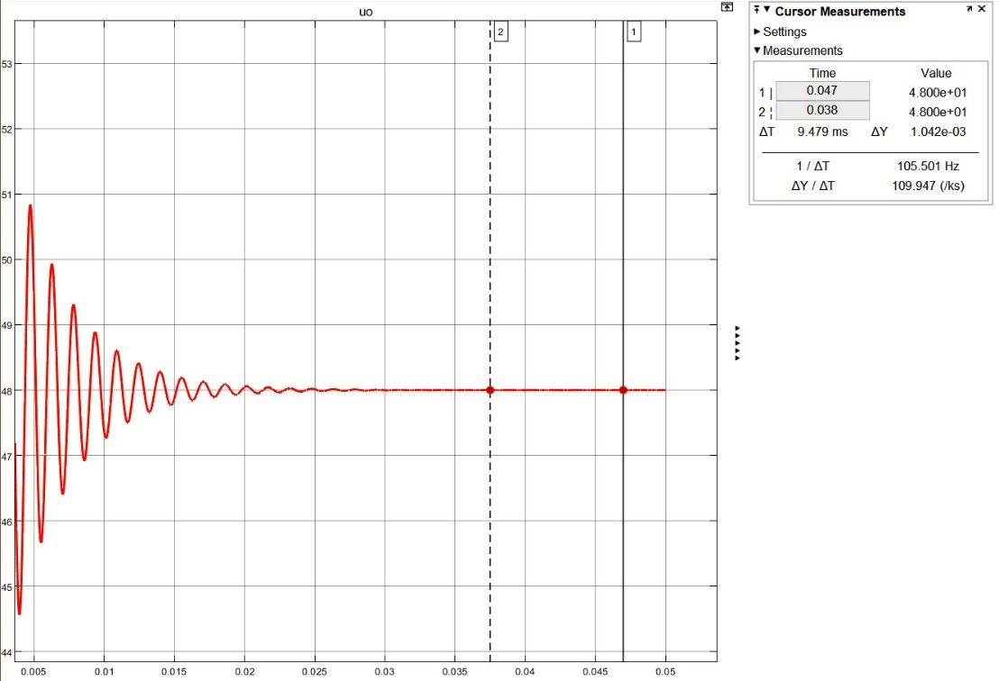

Fig. 2-1 Simulink model for topic2

Afterwards, we got the waveform of inductor current and the detailed waveform of output voltage, which are shown below:

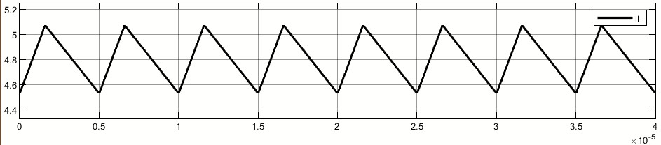

Fig. 2-1 Simulink model for topic2

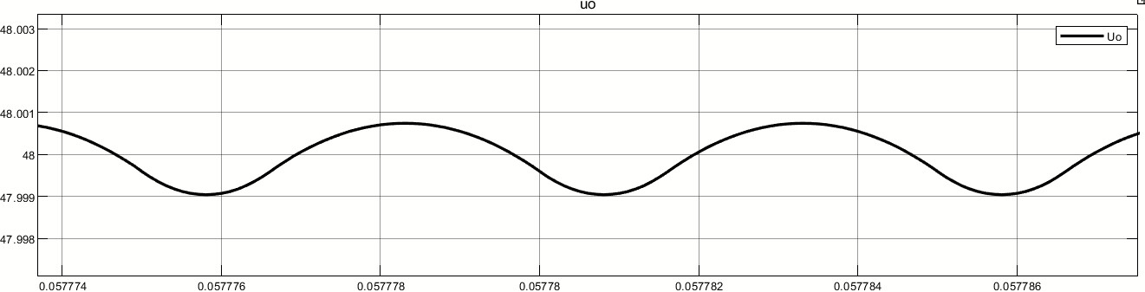

Fig. 2-1 Simulink model for topic2

Given that , so when the inductor is charging, the voltage is positive and when it’s discharging, the voltage is negative. The inductor and capacitor make up a low-pass filter, which makes the output voltage almost a constant value with small ripple, which fits the figure.

***4-2 Task 2***

***4-2-1 Task requirement***

We need to adjust the load resistor to realize continuous current mode (CCM) and discontinuous current mode (DCM) and verify through simulation.

***4-2-2 Theoretical analyzation***

In the indirect DC converter, CCM and DCM is determined by the conductor current. Due to the current ripple, in some case the conductor ripple may be zero and we term this mode is DCM. On the contrary, if the current is always bigger than zero, the mode is termed CCM.

In this part, the circuit consists of a full-bridge inverter and a full-wave rectifier. In order to analyze the inductor current, the circuit can be equivalent to a buck converter. And the equivalent circuit and parameters are shown as below.

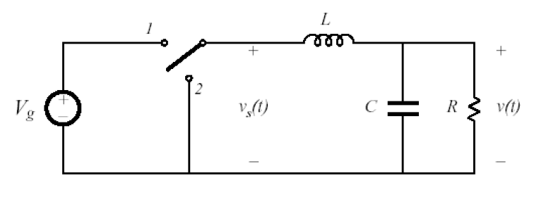

Fig. 2-6 Equivalent buck converter

Tab. 2-2 Equivalent parameters

|  |  |  |
| --- | --- | --- |
| Parameters | Equivalent parameters | Value |
|  |  | 150V |
|  |  | 48V |
|  |  | 0.32 |
|  |  | 200kHz |
|  |  | 10Ω |
|  |  | 300uH |
|  |  | 200uF |

From the former analyzation, we know output voltage ripple is very small, so we can neglect the voltage ripple and think the output is constant voltage .

In Fig. 2-7, we can see the on state of the buck converter.

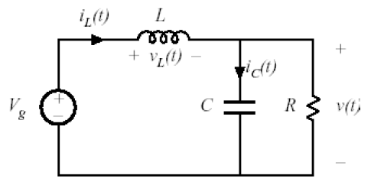

Fig. 2-7 On state of buck converter

We assume output is a constant voltage, so we have

The slope of inductor current is constant

Similarly, at the off state, the slope of inductor current is also constant.

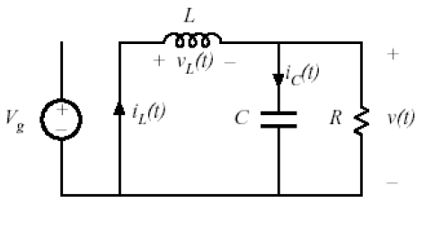

Fig. 2-8 Off state of buck converter

Therefore, the waveform of inductor current is linearly as below.

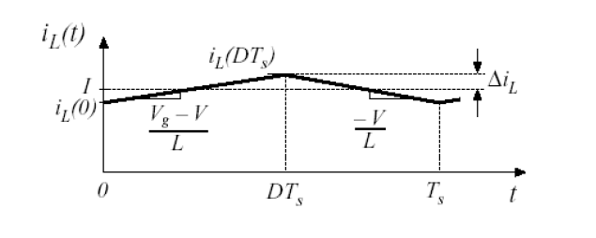

Fig. 2-9 Waveform of inductor current

When the current is continuous, we have

***4-2-3 Simulation verification***

From the calculation in 4-2-2, we could know the critical resistance . We plot the current of inductor and diode when .

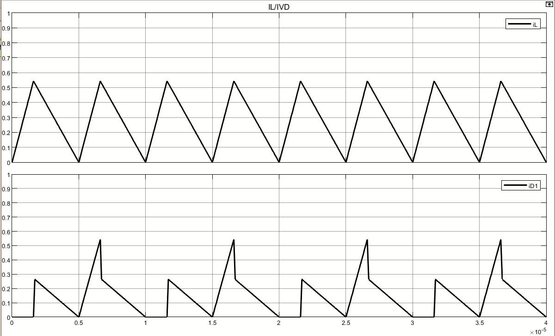

Fig. 2-9 Critical mode current

Afterwards, we select two situations when and

When , the circuit works under continuous current mode. The waveform is shown below:

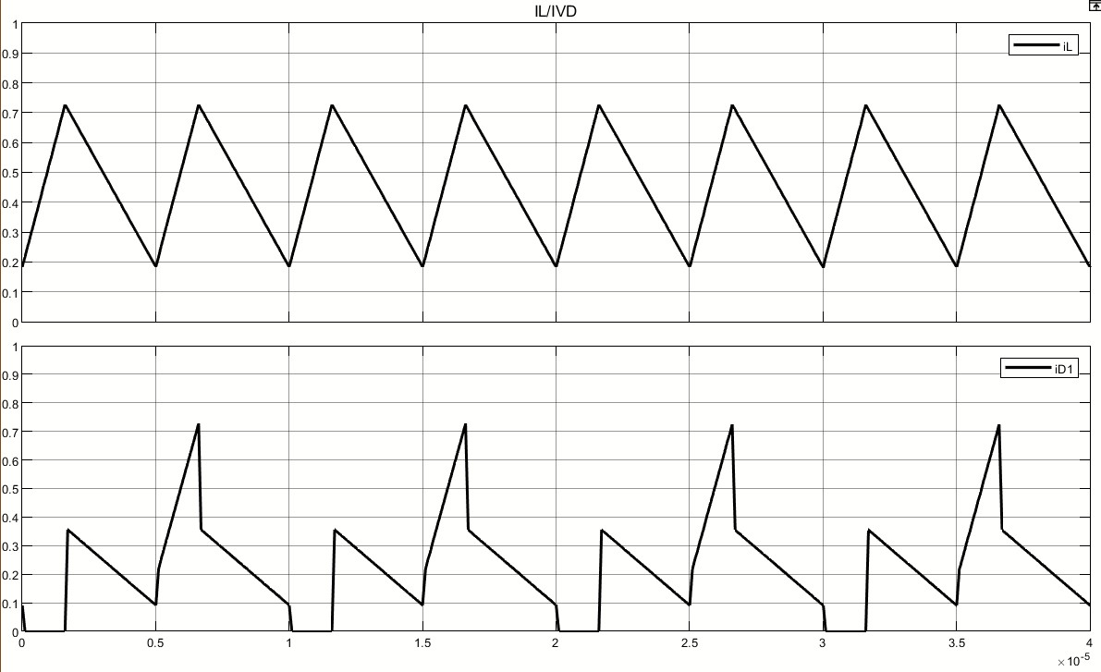

Fig. 2-9 CCM mode current

When , the circuit works under discontinuous current mode. The waveform is shown below:

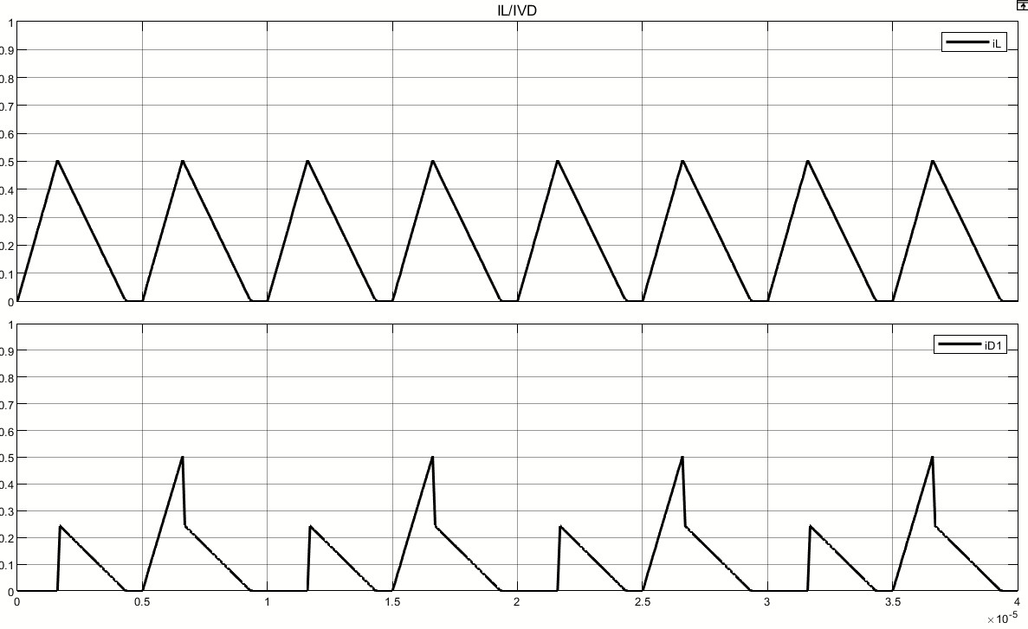

Fig. 2-9 DCM mode current

***4-3 Task 3***

***4-3-1 Task requirement***

In this task we need to adjust duty cycle *D* and analyze the relationships between *D* and voltage gain.

***4-3-2 Simulation result and analysis***

In order to avoid the situation where the four MOSFETs conduct together during the commutation (it may destroy the circuit), duty cycle shouldn’t be bigger than 0.5. We adjust *D* from 0 to 0.5 to carry out the simulation and get the result as below.

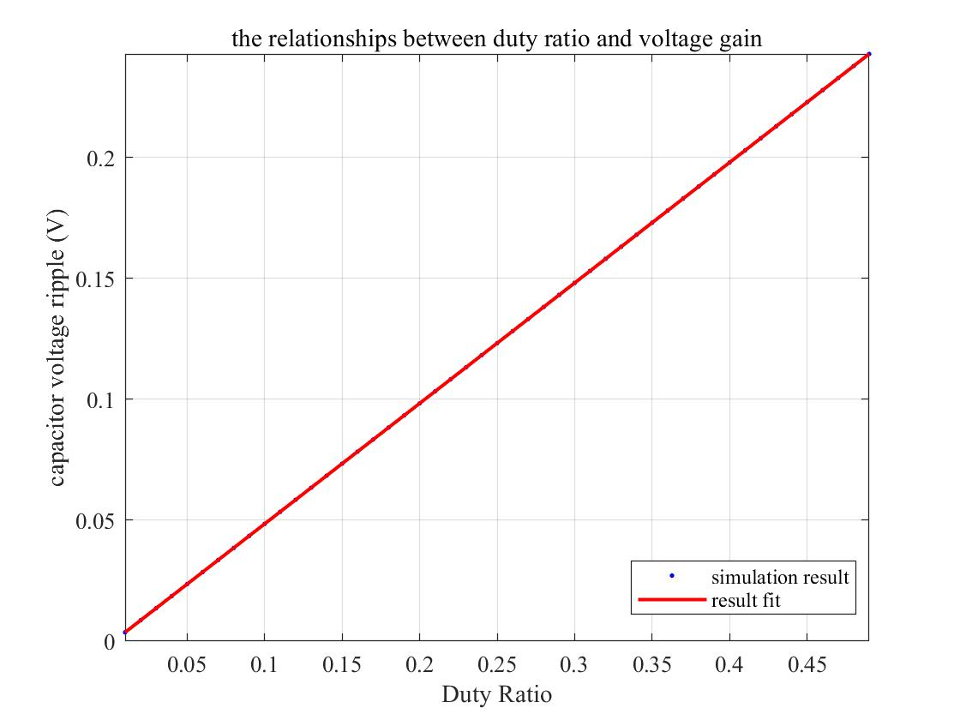

Fig. 2-9 DCM mode current

Through theoretical calculation, we could know that the voltage gain equals to:



For our group, the ratio of transformation . Therefore, the slope of our curve should be 0.5 and from the simulation result we could conclude that the calculation result is almost the same as the simulation result.